1. Tampilkan data Name, Region, Population pada tabel Country dan Language berdasarkan Country Population diatas rata-rata

[SELECT](http://localhost/phpmyadmin/url.php?url=https://dev.mysql.com/doc/refman/8.0/en/select.html) Name, Region, Population FROM `country` WHERE Population>([SELECT](http://localhost/phpmyadmin/url.php?url=https://dev.mysql.com/doc/refman/8.0/en/select.html) [AVG](http://localhost/phpmyadmin/url.php?url=https://dev.mysql.com/doc/refman/8.0/en/group-by-functions.html#function_avg)(Population)FROM country);

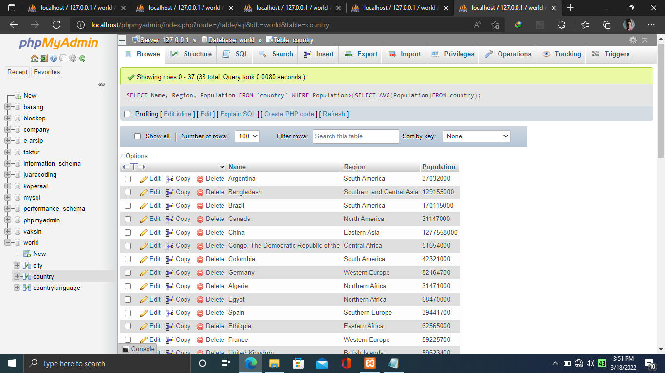

1. Tampilkan data Name, Region, Population pada tabel Country dan Language berdasarkan Country Population diatas rata-rata

[SELECT](http://localhost/phpmyadmin/url.php?url=https://dev.mysql.com/doc/refman/8.0/en/select.html) Name, District, Population FROM `city` WHERE Population>([SELECT](http://localhost/phpmyadmin/url.php?url=https://dev.mysql.com/doc/refman/8.0/en/select.html) [AVG](http://localhost/phpmyadmin/url.php?url=https://dev.mysql.com/doc/refman/8.0/en/group-by-functions.html#function_avg)(city.Population)FROM city);

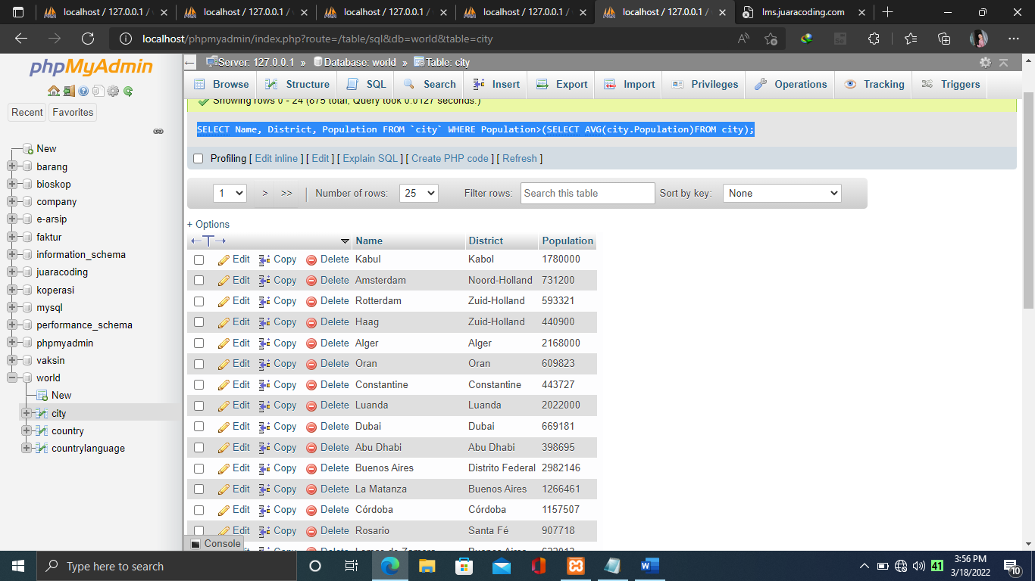

1. Tampilan data Name, Region, Population pada tabel Country berdasarkan IndepYear null

[SELECT](http://localhost/phpmyadmin/url.php?url=https://dev.mysql.com/doc/refman/8.0/en/select.html) Name, Region, Population FROM `country` WHERE IndepYear [IS](http://localhost/phpmyadmin/url.php?url=https://dev.mysql.com/doc/refman/8.0/en/comparison-operators.html#operator_is) NULL;

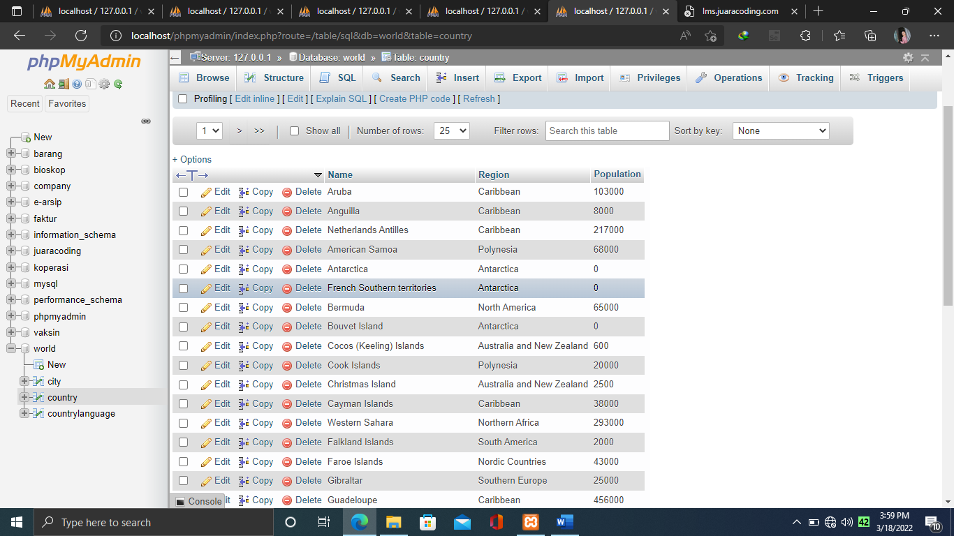

1. Tampilan data Name, Region, Population pada tabel Country berdasarkan IndepYear null